Web-based Human Resource Assistant

# Introduction

The goal of this project is to develop a web-based personality recognition system with LinkedIn data.

The HR department of a company receives hundreds of job applications for each vacancy. The ideal candidates must fulfill the job requirements while having the required personality traits. Nowadays the recruiters leverage LinkedIn to find the perfect candidates for the available positions by either manually visiting profiles which most likely results in human error, or using tools available in the market, which mainly focus on the engagement of the audiences and other marketing related things. So, these approaches are not very effective in regards to identify the personality traits of a user. So most of the time the results can be misleading. The proposed web-based personality recognition system will use a Machine Learning model in the backend and given a LinkedIn username, it will get the required data from the LinkedIn API, preprocess the data and will identify what Big Five personality traits are presented. The recruiter can use the React frontend to enter usernames and receive the generated output report.

People, or the human resource is the most important part of a company. Because it is only by the efforts of people that the other resources and the raw materials can be transformed into achievement, and that the company can succeed. Therefore, recruiting the right people becomes a critical activity in every company. This web-based solution will help companies to identify the right candidates for different types of positions with the right personality types.

Expected List of Features is as follows;

* UX rich frontend
  + The website will be developed by applying interactive and visual design principles for a positive and cohesive user experience.
* A Machine Learning model with high accuracy
  + The whole system depends on the accuracy of the model. So it should be as high as possible.
* A questionnaire
  + A questionnaire should be available to evaluate the personalities of the job candidates, who do not use LinkedIn. Idea is to make the questionnaire open ended so that the same ML model can be used here as well.
* Report generating
  + The recruiter should be able to easily generate a report of the identified personality types.
* Role-based authentication
  + The website should have a role based authentication system since some candidates are also going to use the system to answer the questionnaire and there should be a gap in permissions of a recruiter and a job candidate.

# User Interface Design and Prototype

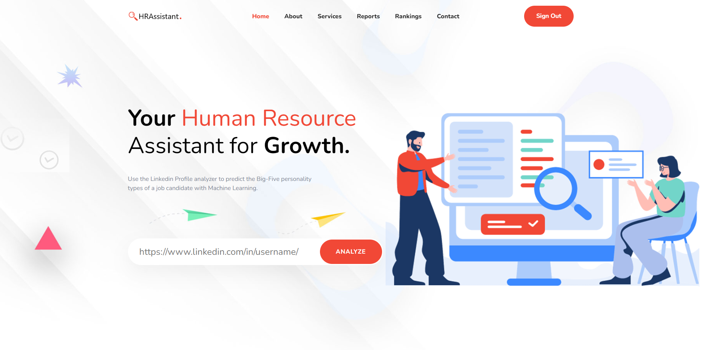

Figure 2.1 Recruiter (Admin) view of the home page

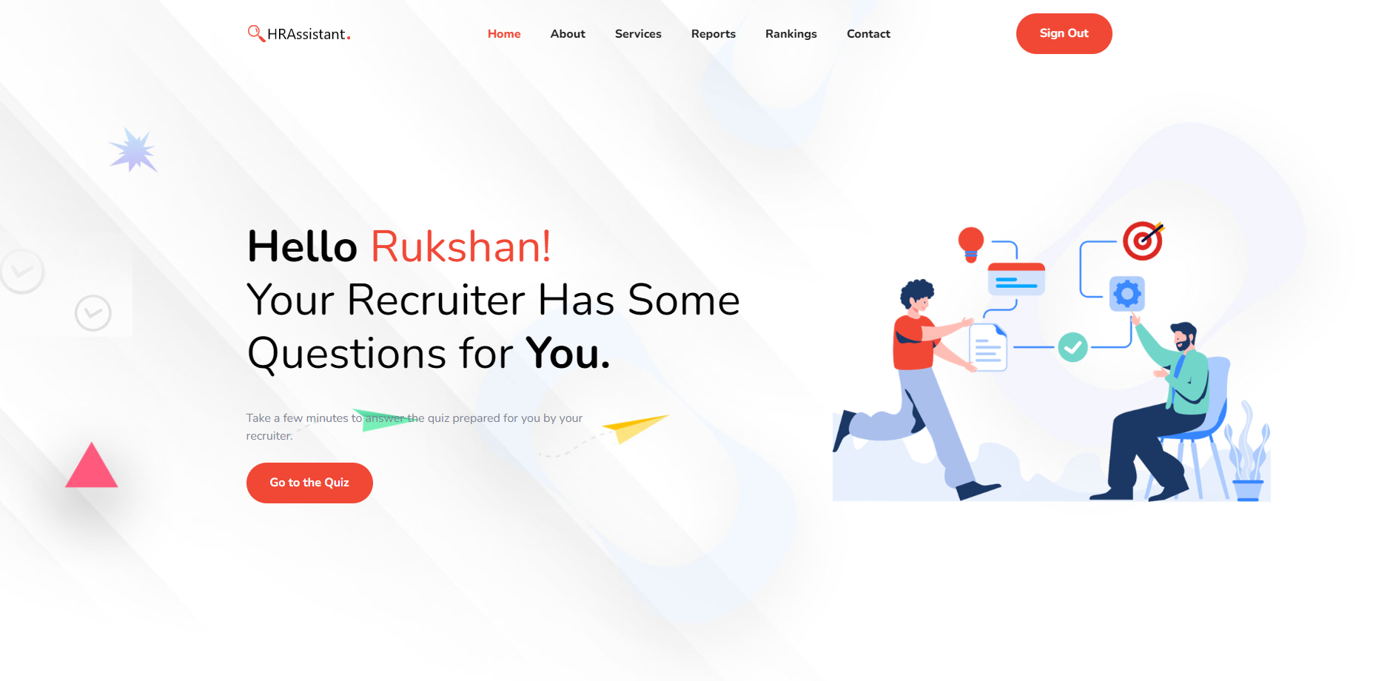

Figure 2.2 Job candidate's view of the home page



Figure 2.3 Login Form

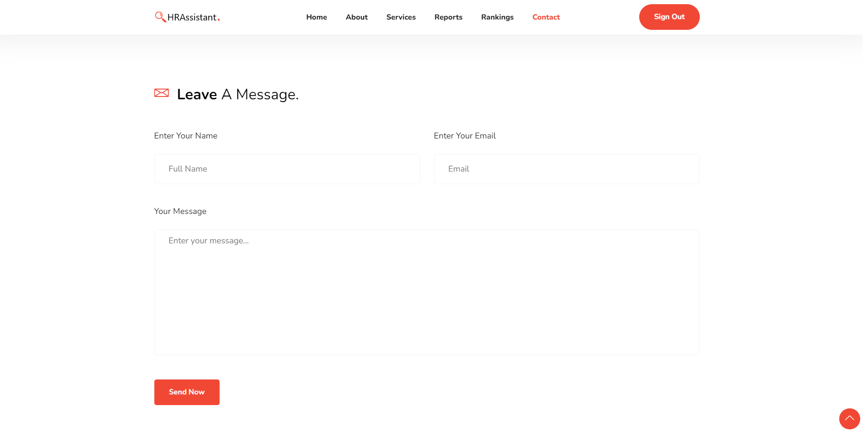

Figure 2.4 Contact page

# Navigation Structure

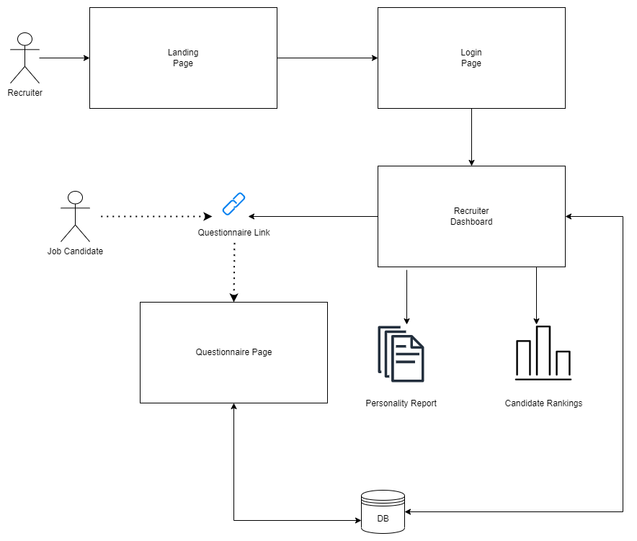

# References

* G. R. Gould, "Finding the right candidate," Records Management Journal, vol. 2, no. 1, 1990.
* <https://www.figma.com/> for prototyping.
* <https://app.diagrams.net/> for navigation structure.